Name: Furthose samreen B

Reg NO: 192511164
Experiment 5 : MoSCoW Prioritization for Library Management System Aim
To categorize the requirements of a Library Management System using the MoSCoW prioritization method based on user impact, feasibility, time, budget, and resource constraints.

Procedure

- Identify the ten requirements of the Library Management System.

- Analyze each requirement based on its importance to users and stakeholders.

- Evaluate the feasibility of implementing each requirement within the available time, budget, and resources.
- Classify the requirements into four MoSCoW categories:

  - Must-Have: Essential requirements.

  - Should-Have: Important requirements that can be implemented later if necessary.
  - Could-Have: Optional features that provide additional benefits.

  - Won't-Have: Features excluded from the current release.

- Record each requirement and its category in an Excel spreadsheet.

- Provide a justification for each classification.

- Review the completed spreadsheet and submit it.

Output

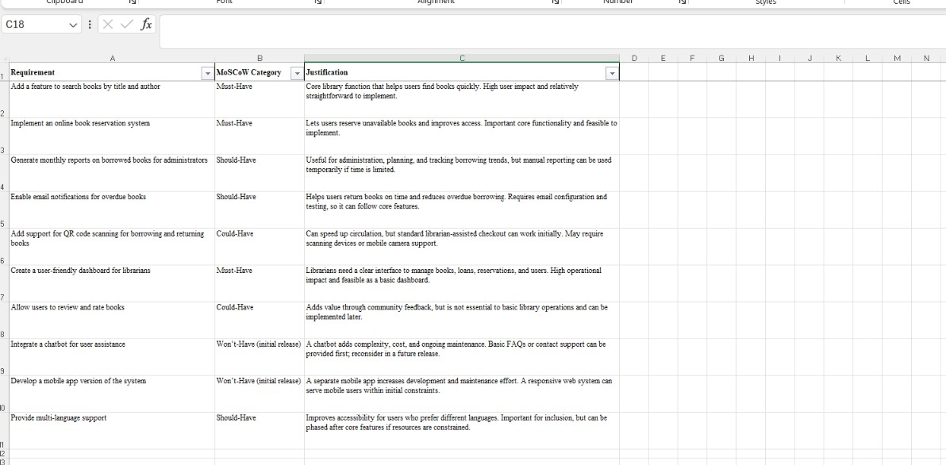

Result

The Library Management System requirements were successfully categorized using the MoSCoW method. Each requirement was prioritized based on its importance, user impact, and implementation feasibility, helping the team plan the project effectively within the available constraints.

GITHUB LINK:
https://github.com/192511164simats-source/Software-engineering-

